Website Proposal

Website Proposal

for

(client company name)

(Appropriate Picture / Logo / Image)

Presented by

(Web development company logo)

(contact details)

Table Of Contents

1.0 |  | Introduction |  | 3
 | 1.1 | About (Web development company name) |  | 3
 | 1.2 | Resources and availability |  | 3
 | 1.3 | The Team |  | 4
2.0 |  | Situation Analysis |  | 5
 | 2.1 | Site Design Methodology |  | 6
 | 2.2 | Fast Loading |  | 6
 | 2.3 | Browser compatibility |  | 6
 | 2.4 | Look |  | 6
 | 2.5 | Precise (right) information |  | 6
 | 2.6 | Information structure |  | 7
 | 2.7 | Interactivity |  | 7
3.0 |  | Proposed Site Flow |  | 8
4.0 |  | Costs |  | 9
 | 3.1 | Domain Name registration |  | 9
 | 3.2 | Web Hosting |  | 9
 | 3.3 | Data refreshment |  | 9
 | 3.4 | Marketing |  | 9
 | 3.5 | Photography |  | 9
 | 3.6 | Site Reporting |  | 9
5.0 |  | Sites for review |  | 10
6.0 |  | Questions |  | 11
7.0 |  | Suggested next step |  | 16
 | 8.1 | Why use us? |  | 16
8.0 |  | General Web Information |  | 17

- INTRODUCTION

1.1 About (Web development company name)

(Web development company name) is a Gold Coast based Website consultancy committed to providing excellence in client service.

(Web development company name) has the ability to draw from an experienced base of personnel whilst maintaining a personalized form of business liaison. The ultimate in consultation, skills diversity and adaptability to meet client expectations are the very strengths of (Web development company name).

(Web development company name) call on a combination of talents, including:

- Client.
- Web Page Designer.
- Copywriter.
- Graphic Artist (if required).
- Internet Marketer.
- Internet user.
- Member of your target market.
- Lay person who does not have any experience with the Internet, to make your site appealing, functional and successful.

1.2 Resources and Availability

Other resources of (Web development company name) include a professionally configured office environment. Multimedia compatible computer hardware, with the latest in software, helps to ensure that the highest quality sites are designed.

1.3 The Team

Jo Bloggs is widely acknowledged as one of Queensland’s top Internet specialists. Jo oversees all aspects of the site development from design to computer programming to marketing.

Web designer Mary Smith is the main designer who would complete the design component of this site. Mary’s experience is extensive and includes time as a teacher of Web design. Mary will also be responsible for the coding of the site in such a way as to increase search engine rankings. This will include placing key words in the site 'meta tags'.

Graphic Design work would also be minimal due to the graphics already available and the nature of the site. Of course, the general feel, navigation and 'look' of the site are completed in close consultation with you.

The time loading of the site (how long for the picture to come onto the computer screen), as well as browser review (can the site be viewed by the vast majority of computers?), would be undertaken by various Internet users throughout Australia. As an example, twelve Internet users throughout Australia using 8 different browsers and various computers with differing modem speeds reviewed the last Website developed by (Web development company name). Only when the site is acceptable to all users is the site passed for hosting (general viewing).

The loading time of the Website onto the computer screen is a major factor that is reviewed.

The site copy would be provided by (client company name).

Once the site is completed, the (Web development company name) team reviews the site from many different angles. From navigation to ease of contact to time loading - every possible angle is reviewed to ensure maximum functionality of the site. This ensures the highest possible viewing rate.

- SITUATION ANALYSIS

(client company name)

From our discussions, we have identified the following objectives:

- Generate leads and sales
- Aid marketing to a world-wide audience
- Aid positioning of (client company name) as a quality business
- Demonstrate the expertise of the team
- Increase ease of contact for prospects and clients
- Provide clients and prospects with easily accessible (and useful) information and tools
- Position the company as technologically advanced
- Aid image development of the company

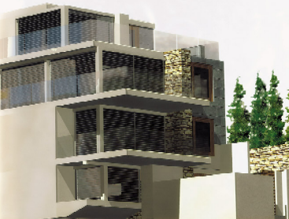
(client company name) will be able to demonstrate a range of properties easily and effectively.

2.1 Site Design Methodology

(Web development company name) recommend that (client company name) set up a system that caters for expansion and flexibility in allowing the content of the site to grow.

As a part of our dynamic development methodology, we identify the following ingredients that make a successful Website. These characteristics can be incorporated into (client company name) site, to fulfill and enhance the objectives above.

2.2 Fast loading

The biggest single reason visitors do not stay at a Website is that it takes too long to load - that is the time it takes for the page to appear on the computer screen. The site needs to be designed around the premise of 'loading' as quickly as possible.

To achieve this (Web development company name) will ensure a strong text base for the pages (text loads very, very quickly). When photographs are used, we will tailor them to be the appropriate size and structure to ensure that they load within an appropriate timeframe.

2.3 Browser compatibility

The site needs to be compatible for viewing across a wide range of user platforms and browser software. We will test the site with many different browsers to ensure that the vast majority of visitors can see the site quickly and easily.

2.4 Look

An Internet site today represents the first contact point for many prospective clients. It is, in a nutshell, showing how professional a company is, and what kind of attitude they have in selling themselves. In full consultation with (client company name), we will discuss the interface and layout of the site with you, to ensure the site is attractive, appealing and reflects the appropriate image.

We utilize extensive usability survey to ensure the site is simple to navigate to encourage usage.

2.5 Precise (right) Information

Along with having an appealing and attractive look and feel to the site, the content of the site must be precisely what the user needs to see. Additionally, search engine positioning must be considered and the site will be developed with key words and placement of same as a consideration.

2.6 Information Structure

A clear, crisp view of the information on the site is paramount in relation to finding specific information on a site. At this early stage, we would anticipate the use of databases to store articles and information of interest.

To provide major benefit to the business, the site should have significant amounts of information available to the user. This information must be easily found and presented in such a way as to encourage use. Information on the site must be able to be quickly and easily update, by (client company name) staff.

2.7 Interactivity

Without interactivity, a Website is purely a book online. Interactive sites capture user details online and monitor what users do inside the system. The more visitors can interact and 'do things' on the site, the more likely they are to revisit.

The importance of having visitors return is found in the statistic that people will buy from you after an average of seven previous visits.

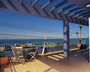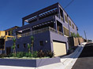

Demonstrating properties to a much wider audience will result in more leads and sales.

- PROPOSED SITE FLOW – subject to ongoing consultation

At this stage, we anticipate a site that is developed using both ‘normal’ Web pages and a database component. The database component means that visitors will be able to be led through the site according to the qualifying and searching you want them to make.

As discussed, the development of any Website is an ever-changing process. The flow chart detailed below is indicative only and is based upon our initial discussions.

✓ | Home | - Brief bio - who, what, when, where, how, etc
✓ | Properties/Developments | - Searchable section of properties
 |  | - Currency Converter
 |  | - Privacy
 |  | - Links to various developments/suppliers as required
✓ | Latest News | - Specials (would be a category of the cart)
✓ | Frequently Asked Questions | - FAQ  - Contact Us
✓ | About SE Queensland | - Information as discussed
✓ | About Us | - General info  - Quality Assurance/Quality Practices/Sales copy
 |  | - Contact Us

The site would also be searchable, have a 'Tell a friend' function enabled and have a newsletter/email database collection facility.

Other features:

- Property of the week.
- Buying tips.
- Recent sales.
- Email me similar properties/properties that meet certain criteria.

4.0 COSTS

Aside from the site development, the costs of the site include:

4.1 Domain Name registration

The domain name www.companyname.com and www.companyname.co.uk are currently available.

(Include prices of registering domain name).

4.2 Web Hosting

Hosting of a site of this size and complexity is $(price) per annum.

4.3 Data refreshment

Fresh data needs to be added to the site very regularly to aid the repeat visits by interested parties. As discussed, we will develop some of the site as what is called a Web based browser database that you can use to edit/add/delete some pages.

We will provide training to ensure that this can be effectively completed.

4.4 Marketing

This should include such aspects as identifying and arranging reciprocal links, search engine submissions, providing off-line and marketing ideas such as postcard mail-out.

A key aspect of Internet marketing for many sites is high search engine rankings. The site would be designed in such a way as to maximize its potential for the highest possible rankings. In our experience, we have found submission of the site to multiple search engines as the most successful way to increase visitor numbers to the site.

4.4 Photography

As indicated, photographs of various properties, people and situations will need to be obtained for the site. Digital photography required for general site work is included in the quote.

4.5 Site Reporting

Detailed statistics can be obtained from the company hosting the site for free.

5.0 SITES FOR REVIEW

[Here include the Web address and screen shots of some of your best sites to help illustrate your expertise.]

6.0 QUESTIONS

What should we look for in a Website Development firm?

One of the major frustrations for clients occurs when they receive wildly varying quotes for Web design projects. One of the best ways to avoid this, and ensure the work is completed to the highest standards, is to specify accurately all aspects of the work to be completed.

The old cliché of comparing apples to apples rings true. Note down the exact specifications for the project, how many pages you require, how many forms, etc. Only by doing that will you ensure that everyone is quoting the same and only then can you really see who is the best value - without compromising on quality.

Having said that, we usually only establish the exact needs of our clients after several meetings and discussions. It can be very difficult for people inexperienced with the Internet to know exactly what can be done to serve best your specific needs. Beyond this, you need to consider various other factors.

These may include:

Experience of the team.
Expertise of the team.
Past projects completed.
Success of previous projects.
References and testimonials.
Equipment - does the designer have all the equipment necessary to complete all aspects of your project? This could include digital cameras, scanners and software.
Specialist skills (i.e. Search Engine placement skills, 'Flash' programming experience).

As an example, our Web Team consists of a researcher, copywriter, Internet Marketer, Web designer, Internet Security Expert and Graphic Artist. A site completed by us is reviewed extensively by our experts for such critical issues as load time (how long does the site take to come up onto the screen?), browser compatibility (is the site displayed the same by different computers?), and navigational ease. Most of our sites are reviewed regularly by a focus group of up to 30 people with various levels of Internet usage skills. With these extensive skills and review, sites completed are of the highest quality.

A lot of people have Web design skills now. Why shouldn't we use a graduate who has these skills?

We do find that this is one of the most common scenarios we are presented with. Our answer is that design skills are only a very small part of Website development. It is no good having an attractive site if it does not attract visitors.

The process we go through in designing a site is exhaustive. Firstly, there are a series of meetings with clients to establish exactly what they want and need the site to do. Once the objectives of the site are clearly fixed, we research the target market and assess their requirements for such a site. We then establish a focus group of the target market that assists in the development of the site. This group completes a series of surveys to identify issues such as load time, copy effectiveness, navigational ease, and the quality of product presentation and overall design success.

In close consultation with our clients, we then move on to complete the look and 'feel' of the site.

The wording of the site is completed by an experienced copywriter. The copy is developed in association with the client and our expert Internet Marketer to ensure that the site will place as high as possible in Search Engines, if this is relevant, and to ensure its relevancy. Privacy commitments are then included into the site (again, research shows that privacy is the biggest concerns for Internet users).

Our Security Expert is brought in to try to 'crack' the site code, access databases, etc to ensure a high level of security is provided for the site.

The entire site is then reviewed via a complex process whereby a vast amount of technical information is gathered and assessed by our team.

Once the site passes a series of strict criteria, ranging from security issues, to navigational issues, to marketing issues, then the site is passed for hosting.

Clients are involved in the development of the site as much as possible, to ensure it meets the objectives set earlier and is a site of the highest standard.

How long would it take to build a site as detailed here?

The site would be completed within three weeks from the order being received. The time of completion quite often depends on the time it takes to develop graphics.

Once the site is up and running, what do I have to do to maintain it?

The site needs to be marketed on an ongoing basis. Fresh information also needs to be put into the site to keep it up to date and interesting. You can do this yourself if (client company name) has the resources available in-house, or we would be delighted to be of assistance.

What are the demographics of people using the Internet?

This varies greatly depending on what research you happen to review.

Some data on Internet users:

44% have income above $70,000 (AUD)
65% of users are male
Average age: 33

46% of adult males (3.0 million) and 36% of females (2.5 million) accessed the Internet in 1999 (this is an increase of 700,000 males and 600,000 females from 1998 figures).

The business community has the fastest uptake of the Internet of any group.

What is a 'host'?

This is the term given to the company that actually puts your Website into cyberspace. Think of the Website as a newspaper advertisement a copywriter has produced for you. You then need to place that advertisement into a newspaper for it to be effective—that's the same as your Website host.

Like newspapers, there are some good hosts and some that could be a little better. The important aspects to know about your host are a) can they cope with the 'type' of site you have, b) will their system be able to cope with the number of visitors your site attracts, and c) do they provide back up service in case of problems?

Are they an ISP (Internet Service Provider)?

Sometimes, ISPs do host Websites (the majority does). Others, such as (host name) (Australia's largest hosting company), only host sites. With this company, you will still need your ISP for email, connecting to the Internet and Web viewing.

What's ecommerce?

Ecommerce is simply the term given to purchasing products or services over the Internet.

What's a link?

A (hyper)link is a bit of text on a Web Page that, when clicked on, takes you to another Web Page or Website.

What's a search engine?

A search engine is a computer that reviews (and ranks in an order) the content of Websites. If a person enters 'golf' into a search engine, that person will be shown a list of sites to visit that contain the word golf. As an example, Yahoo! (the most popular search engine on the Internet) has 2,066,797 Web pages to choose from when 'golf' is searched for.

What's Web surfing?

Web surfing is the term given to reviewing Web pages by going from one link to another. A recent Website we did for a client contains a link to the 'Marriott Resort.' From here the surfer can go to the 'Dreamworld' site, onto the 'Antarctic Adventure' site, from here to the 'Australian Bureau of Meteorology' and on it goes.

Will the Internet continue to grow?

All indications are that the Internet will continue to grow. Most day to day activities can now be completed on the Internet. An example of this is grocery shopping from the major supermarkets. Think of when the first fax machines appeared. When only a few had them not everyone needed them—but when the majority had them then others had to have them to keep in step.

Increasing ease of use, reducing costs and technological advances will aid the continued growth.

Is it important to get people to return to the site? If yes, how do you get them to return?

It is vital to have people return to the site again and again. Research indicates that people will feel more comfortable with your company and purchase products or services only after having visited the site seven times previously.

To have people return to the site we have to reward them. We have built-in some strategies to the proposed site that will aid repeat visiting. Other possibilities include:

- Interesting information regularly updated such as industry related articles, tips as said, etc.

- Links page containing links that appeal to the target market - once visitors know it is available they can return to the site to access the links easily.

How do people find out about Websites?

- 90% from links from other sites
- 85% from search engines
- 65% Word of mouth
- 64% from magazines and newspapers
(Multiple response answers)

How do we let people know of the site?

As indicated in the above figures, effective marketing of a Website is achieved utilizing a variety of techniques. These include:

Links - being linked to a site that has a lot of, and/or related, visitors can attract visitors over to your site. Examples of the reciprocal links we will try to establish are with:
- Suppliers.
- Clients.
- Sites of interest.

Search Engine submission - up to 85% of all Websites are found after a search engine request.

Structure of the site - the text and meta tags (meta tags are special areas hidden within a site that hold key words that search engines find) should hold all words that are relevant for your site.

Off-line advertising - advertising of the site, placing the Website address on all business literature, using a 'postcard' mail out strategy, etc.
7.0 SUGGESTED NEXT STEP

The next step is to review others sites, speak with industry sources and generally assess the way our proposal provides the solutions to taking (client company name) into the market of tomorrow today - the Internet.

The Internet is a sometimes mystifying and complicated world—we welcome any questions or suggestions you may have regarding this proposal. We would be delighted to provide additional information on how we can make the (client company name) Website the best it can be.

We can be contacted on (phone number), facsimile (fax number), and email (email address).

7.1 Why use us?

We have the expertise and experience to ensure the trouble-free and effective management of your Website - from conception to ongoing management. The team, as detailed in 1.0, is highly professional and committed to the highest standards. We have identified the requirements of the site and developed an appropriate strategy to ensure these needs are met.

From expert designers to copywriters and Internet marketers we have the team to ensure the highest quality site at a very competitive rate. We know the pitfalls; we know the shortcuts. Use the team to cut through years of frustrating trial and error.

Here are a few comments to consider.

"Our previous Internet site drew only 700 hits in a whole year. After (Web development company name) redesigned the site we had 108,000 hits in the first month alone. We are stunned by the reaction to the site!"
Name, Position, Company.

"Very positive feedback and we are well up on the number of visitors…"
Name, Position, Company.

"Since you re-developed the site we get 3 times as many bookings…great work, great site. Thanks!"
Name, Position, Company.

8.0 GENERAL WEB INFORMATION

[Include general statistics of Internet usage percentages.]

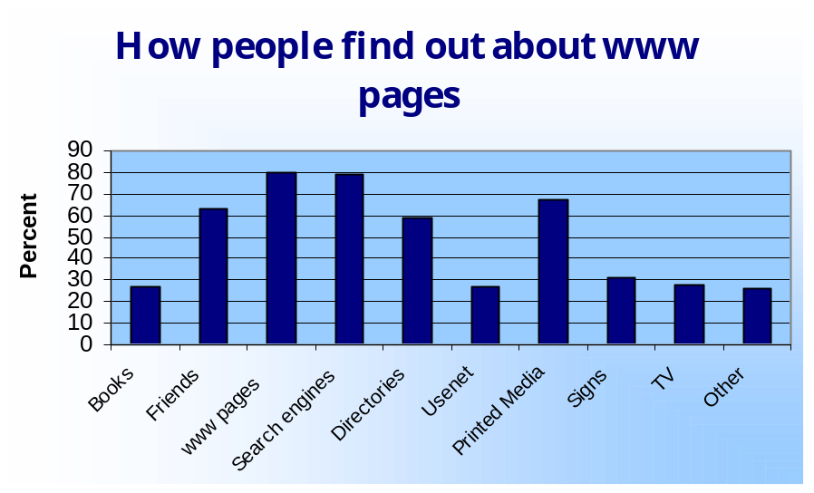How do people find out about Websites?

Figure 1: How people find out about www pages
Source: GVU's 10th WWW User Survey

Figure 2: What is the primary way you discover new Websites?

Method | % of users surveyed
Search Engines | 46.0
Word of Mouth | 20.3
Random Surfing | 19.9
Magazines | 4.4
By accident | 2.1
Newspapers | 1.4
Television | 1.4
Email | 1.2
Banner ads | 0.9
Other | 19.9
Don't Know | 0.7
Radio | 0.4
Source: Channeleven.com, survey 22/2/00

Figure 3: Most effective methods of finding Websites

Search Engines | 3.35
Opt-In Email | 3.34
Offline Advertising | 3.04
Press Release | 3.00
Banner Advertising | 2.85
Discussion forums | 2.83
Sponsorships | 2.61
Newsgroups | 2.46
Strategic linking | 2.44
Spam | 1.83
Source: Gold Web Research

Figure 3 is from a survey of Web marketers on how they rated the over-all effectiveness of the following methods on a scale of 1 to 5, with 5 being the most effective.

Figure 4: Most frequently used navigation method

Source comparison: Most frequently used navigation method
Navigation method | According to GVU7 | According to CommerceNet | According to eStats
Search Engines | 87% | 71% | 75%
Other Web pages | 85% | 8.4% | 68%
Printed Media | 63% | 8.5% | 44%
Friends and relatives | 53% | 9.3% | 53%
Usenet | 32% | 3.3% | 12%
Television | 32% | 2.6% | 1%
Email | 32% | N/A | 32%
Books | 28% | N/A | 1%
Other | 28% | N/A | 7%
Source: eReports 1999

Buying Online

Figure 5: Barriers to Online Purchasing

Barrier | Level of Significance
Pricing | 77%
Potential return hassles | 67%
Credit card concerns | 65%
Privacy issues | 58%
Navigation difficulty | 35%
Time to receive orders | 25%

Source: The Intermarket Group 1999

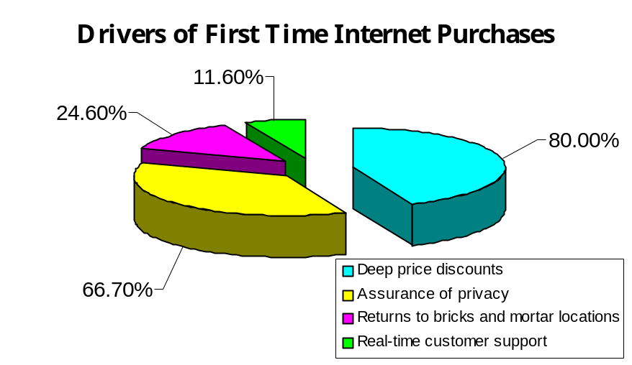Figure 6: Drivers of First Time Internet Purchases

Source: NFO Interactive

Figure 7: Gender and age of first time Internet buyers

Gender of first time buyers
Women | Men
56% | 44%
Ages of first time buyers
Age Group | Percent
Under 30 | 14.5%
30-39 | 25.4%
40-49 | 29.7%
50-59 | 21%
Over 60 | 9.4%
Source: NFO Interactive

Figure 8: How consumers find ecommerce sites

How consumers find ecommerce sites
Type URL directly | 60.0%
Bookmarks | 48.1%
Search Engines | 42.2%
Banner Ads | 14.0%

